Is Investing Your Time in Learning Angular Worth It?

In recent days, there has been a lot of buzz about Javascript frameworks. The use of Javascript frameworks can drastically shorten your development time and improve your code base and application quality. Angular is one of the preferred frameworks among web developers.

Here is the chart that shows the Angular job trend growth over the years.

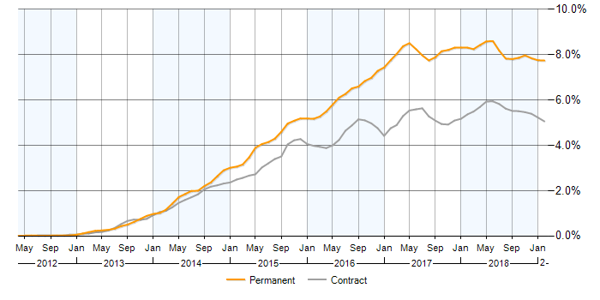

**Image Source:** [IT Jobs Watch](https://www.itjobswatch.co.uk/jobs/uk/angularjs.do)

Angular is not going away anytime sooner. If you want to go ahead and capitalize on the growing demand of Angular developer, you should strongly consider joining a top-notch course, such as [**Simplilearn online angular certification training course**](https://www.simplilearn.com/angular-certification-training). You will have a strong foundation that you need to get started once you complete the course.

Before that, you should finish going through this article to understand deeply about the impressive power of Angular.

## What are some key reasons to Shift to Angular?

Not every framework is right for everyone. In this section of this article, I will reveal some of the critical benefits of shifting to Angular and how it can impact your web and mobile app development project. Here it goes:

1. **You can boost your app performance via a single page application**

The modern-day users are incredibly cautious when it comes to app performance. They do not want to browse websites and applications that are slow to load. The single page application is one of the types of web applications that is capable of loading only a single HTML page at a time.

In a single page application, your HTML page will update dynamically, according to the interactions of the user with the page. The app does not need to refresh now and then for communicating with the back-end server.

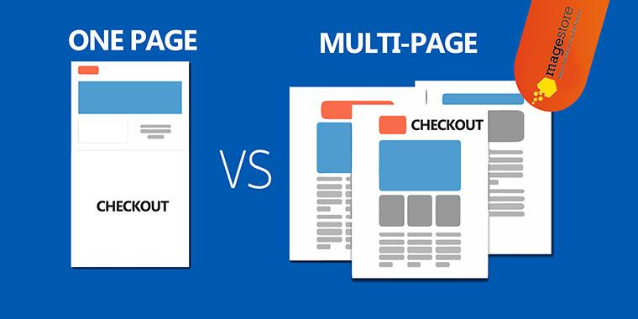

**Image Source:** [Magestore](https://blog.magestore.com/comparison-between-one-page-checkout-and-multi-page-checkout-process-which-is-suitable-for-your-website/)

The user experience will drastically improve if you shift from a multi-page app to a single page application. Ideally, your app should load a page under 2 seconds ([Source](https://www.hobo-web.co.uk/your-website-design-should-load-in-4-seconds/)). Anything above 2 seconds of page load time can negatively impact the user experience.

Angular supports this feature. Are you excited yet? Let’s move to next points to arouse more interest in you.

**2. Automate the process with two-way data binding**

The recent Angular versions make use of the ngModel directive for implementing the two-way binding feature. It is a powerful feature in Angular that enables automated retrieval and updates from data storage. What this means is that your UI will automatically update itself instantaneously once you store something.

There is no hassle for you to update your UI every single time you store something manually. It will enhance your productivity as a developer.

**3. You can keep your code base much, much cleaner**

The [study](https://www.inc.com/larry-alton/waning-productivity-could-a-messy-desk-be-to-blame.html) shows that an average person wastes around 4.3 hours of their weekly time for searching papers and documents. We can transfer the usability of this study to coding as well. An unclean code can waste a lot of your time as a programmer, which will reduce your productivity.

With the modularity feature of Angular, you can be much more productive. You can organize your codes into multiple reusable modules. The module consists of pipes, related components, directives, and services bundled up together to make things easier for you.

There are more features of modules besides modularity. You can take advantage of a lazy-loading. What is lazy-loading? It allows one or more characteristics of an app to load on demand. A lazy-loading feature can significantly enhance the application efficiency.

If you check out the list of popular applications that use Angular, you will find many famous brands. To name some of them, they are Freelancer.com, Netflix, Upwork, PayPal, The Guardian, and so on. I believe most of you are familiar with these websites.

These large applications need multiple teams to update, monitor, and maintain codes. The modular feature of Angular allows the corporations to divide different modules to different groups, making a job easier for the developers.

**5. Faster Development time**

Faster development time is crucial for both corporations and developers. You want to make more money in a lesser time, while corporations want to get started as soon as possible. The Angular Framework offer benefits to developers by reducing manual coding, which will allow companies to use them quickly.

However, the reduced coding does not mean an ineffective code. The codes are incredibly efficient. You can work with Model View Controller (MVC) architecture via Angular. The MVC architecture allows the programmers to divide the codes, according to the MVC structure. That’s it. After that, Angular does its part. The coders do not need to produce a separate MVC pipeline as well.

**6. The use of the declarative user interface**

HTML is simpler and more intuitive than Javascript. The Angular framework uses HTML to define the user interface in an app. It makes things easier for developers to create a user interface.

Angular framework distinguishes between presentation logic and imperative logic. There is no need for you to worry about the app component flow and the order loading. Your only task is to define the page layout about the data-bound location along with the location where it is bounded. You have completed your work. After that, you can rely on Angular to do the rest of the task for you.

**7. It is no brainer to integrate third-party frameworks**



**Image Source:** [**Hackernoon**](https://hackernoon.com/angular-providers-how-to-inject-3rd-party-library-af4a78722864)

There are times that you want to integrate Angular with third-party frameworks to create an app with more features or to utilize the power of other frameworks. You can do that easily without scratching your head.

The integration is pre-built in Angular with many frameworks, such as Wijimo, Ionic, Telerik’s Kendo UI, and so on. If you want to experiment with other frameworks’ features and borrow some impressive UI components from them, you can do that without any hassles. The only thing you need to do is spend a little time with the integration process and experiment.

**8. Code once and run anywhere**

The reason why cross-platform web apps and mobile apps are getting popular is because of its flexibility. There is no need for you to maintain a separate code base for different operating systems. You can code once in Angular and run the app in all popular operating systems.

Apart from web development, you can also create a progressive web app with Angular that can run offline. If you want to build a native mobile app, you can also do that with Angular. We have got a mobile and web app. Can we create a desktop app with Angular? You can do that too.

It is possible for you to create desktop applications with Angular. You can run the app on Windows, Linux, and Mac. What else do you want?

## Over to You

Currently, the popularity of both web apps and hybrid mobile apps are going up. The businesses are starting to realize the power of cross-platform mobile apps and how they can reach out to their customers via both websites and apps.

As a developer, you must respond to the demand of the market. Learning Angular will not only enhance your productivity as a developer, but it will also broaden your scope. If you find the points that I have revealed appealing, go ahead and start learning Angular.